Basic Networking Interview Questions
1. What is a Computer Network?
A computer network is a collection of interconnected devices that communicate and share resources like data, printers, internet, etc.

2. What are the types of networks?
- LAN – Local Area Network (small area, office/home)
- MAN – Metropolitan Area Network (city-wide)
- WAN – Wide Area Network (large area, internet)

3. What is the OSI Model?
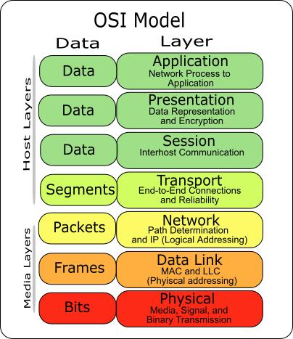
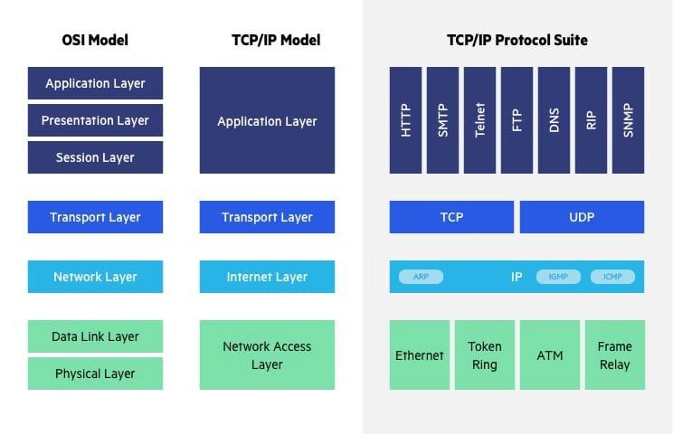
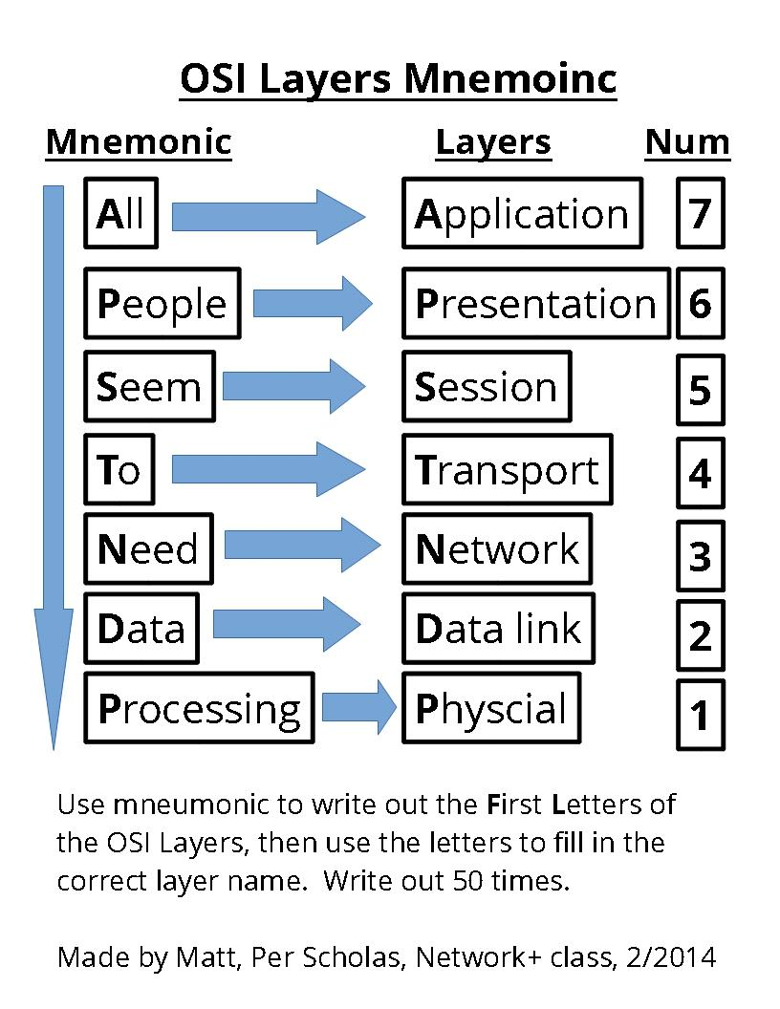
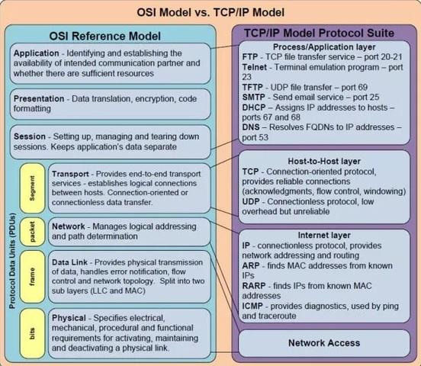
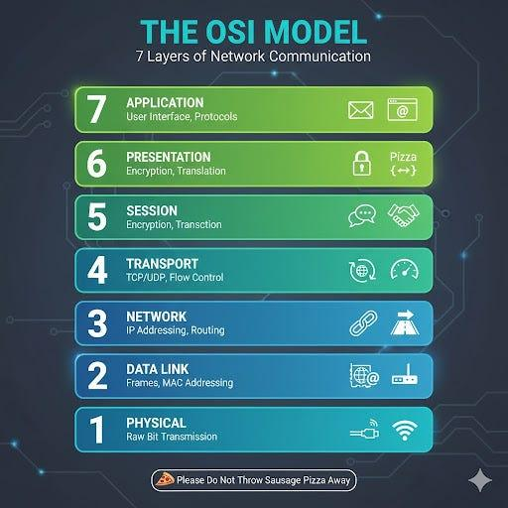
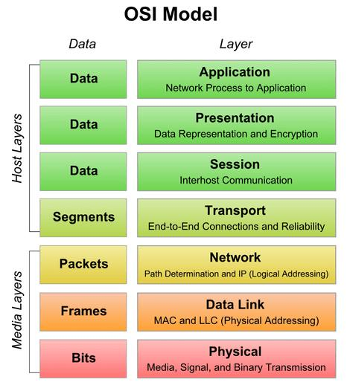
OSI has 7 Layers:
- Physical Layer
- Data Link Layer
- Network Layer
- Transport Layer
- Session Layer
- Presentation Layer
- Application Layer
Mnemonic:
Please Do Not Throw Sausage Pizza Away

4. Difference between OSI and TCP/IP Model
OSI | TCP/IP
7 Layers | 4 Layers
Conceptual model | Practical model
Reference model | Protocol suite
TCP/IP Layers:
- Network Access
- Internet
- Transport
- Application

5. What is IP Address?
Unique address assigned to a device in network.
Example:
- IPv4: 192.168.1.1
- IPv6: 2001:db8::1

6. Difference between IPv4 and IPv6
IPv4 | IPv6
32-bit | 128-bit
Uses dots | Uses colons
Limited addresses | Huge address space

7. What is MAC Address?
Physical address of Network Interface Card (NIC).
Example:
00:1A:2B:3C:4D:5E

8. What is DNS?
Domain Name System converts website names into IP addresses.
Example:
google.com → IP Address

9. What is DHCP?
Dynamic Host Configuration Protocol automatically assigns:
- IP Address
- Subnet Mask
- Gateway
- DNS

10. What is Subnet Mask?
Divides network and host portion.
Example:
255.255.255.0

11. What is Default Gateway?
Router IP used to communicate outside local network.

12. What is TCP vs UDP?
TCP | UDP
Connection oriented | Connectionless
Reliable | Fast but unreliable
Acknowledgment | No acknowledgment
Examples:
- TCP → HTTP, FTP
- UDP → Video streaming, Gaming

13. What is Three-Way Handshake?
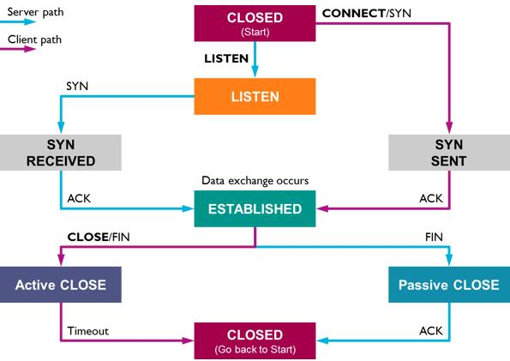
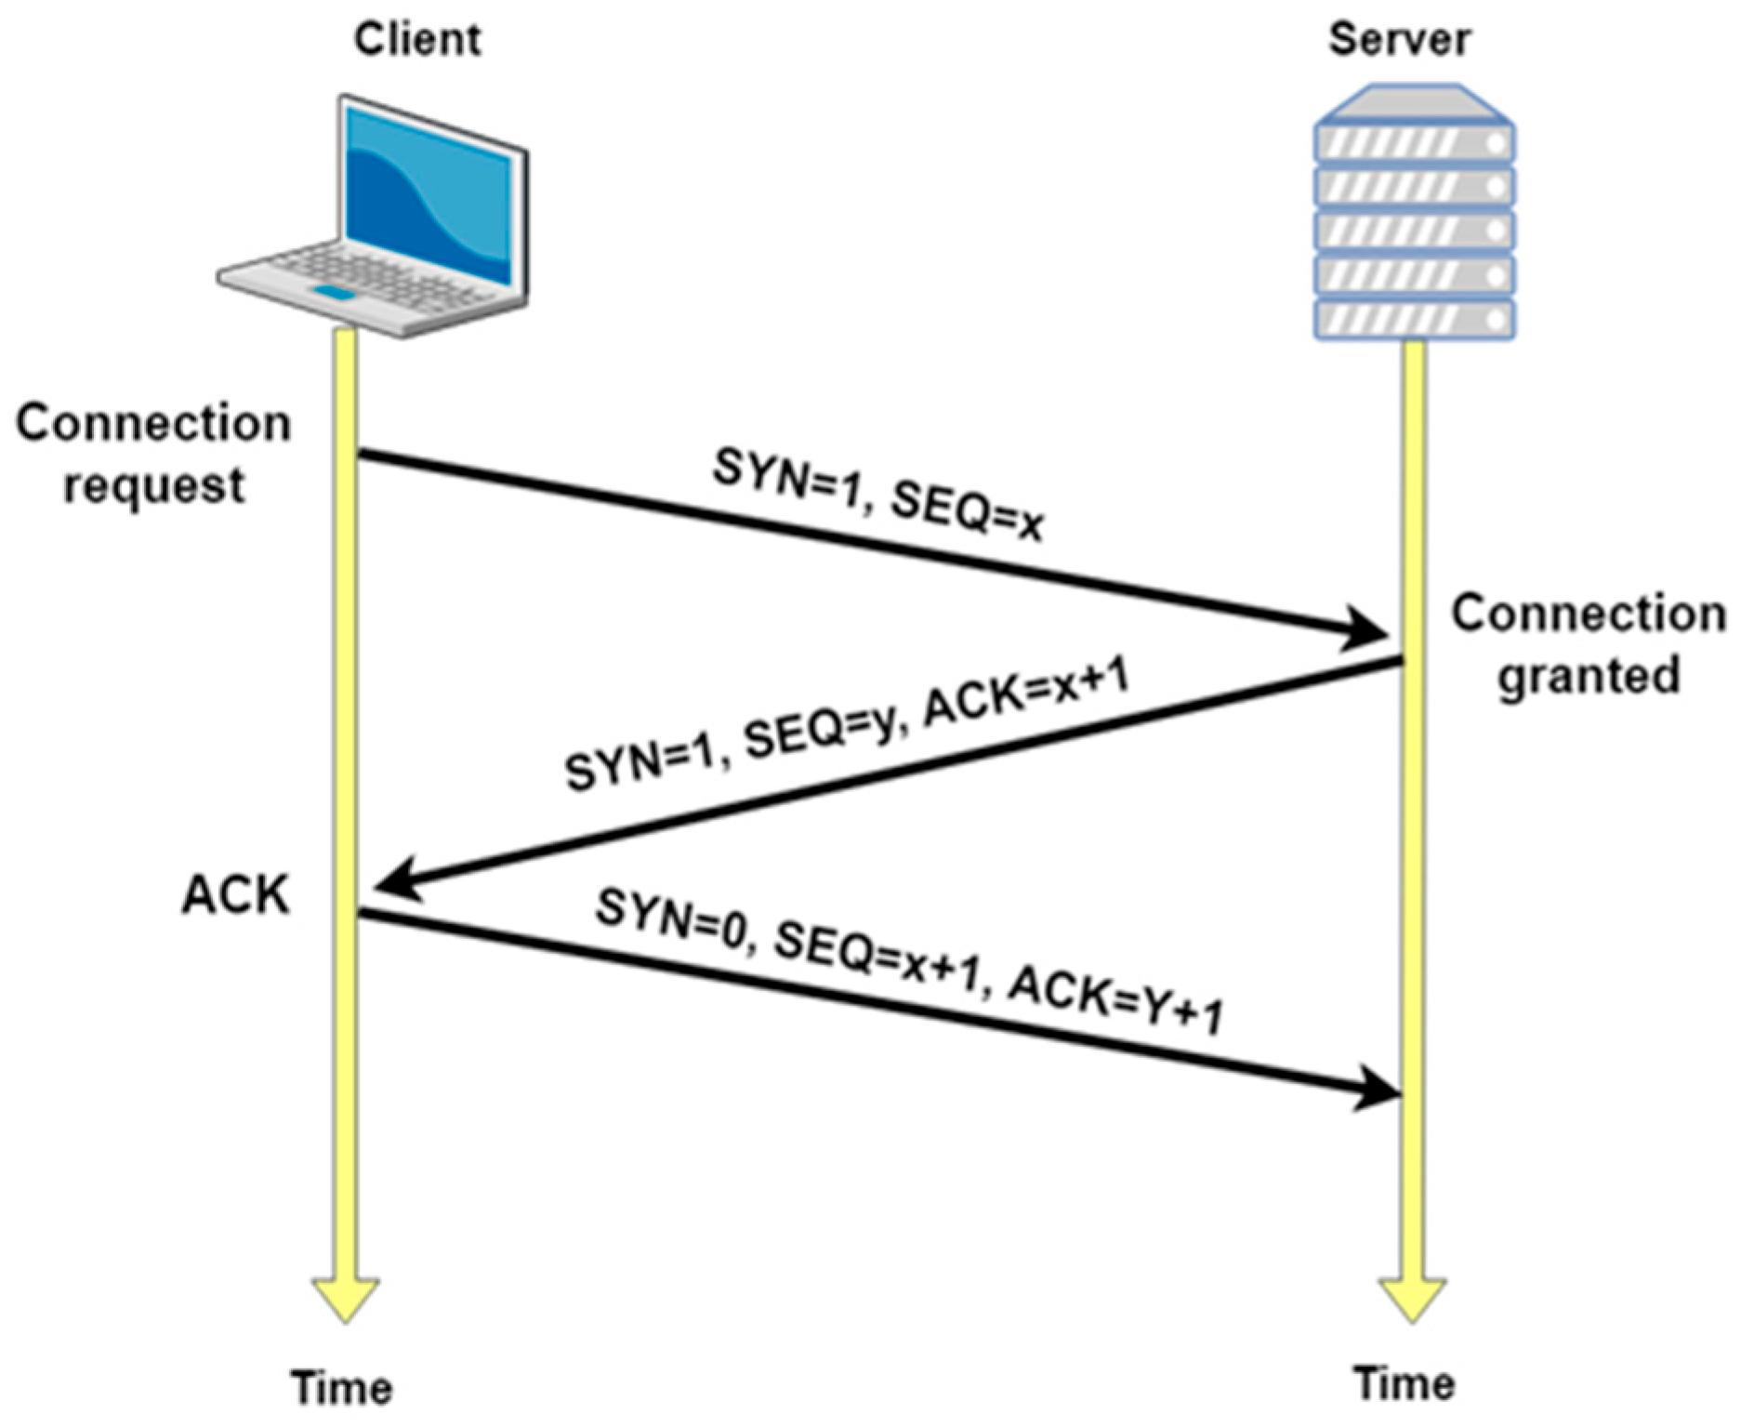
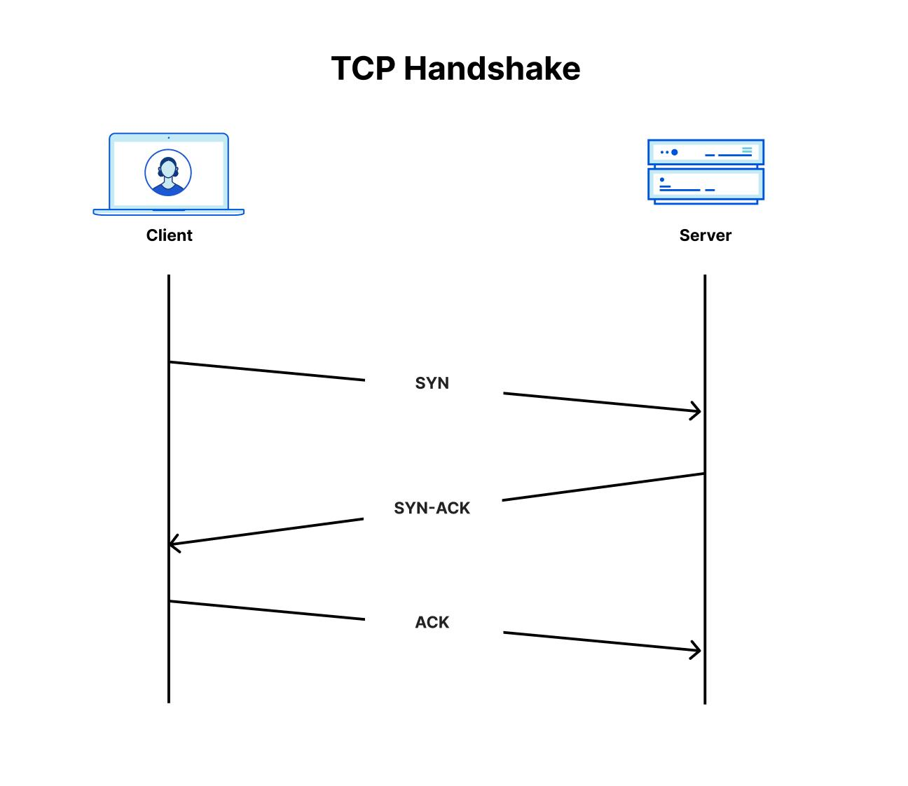
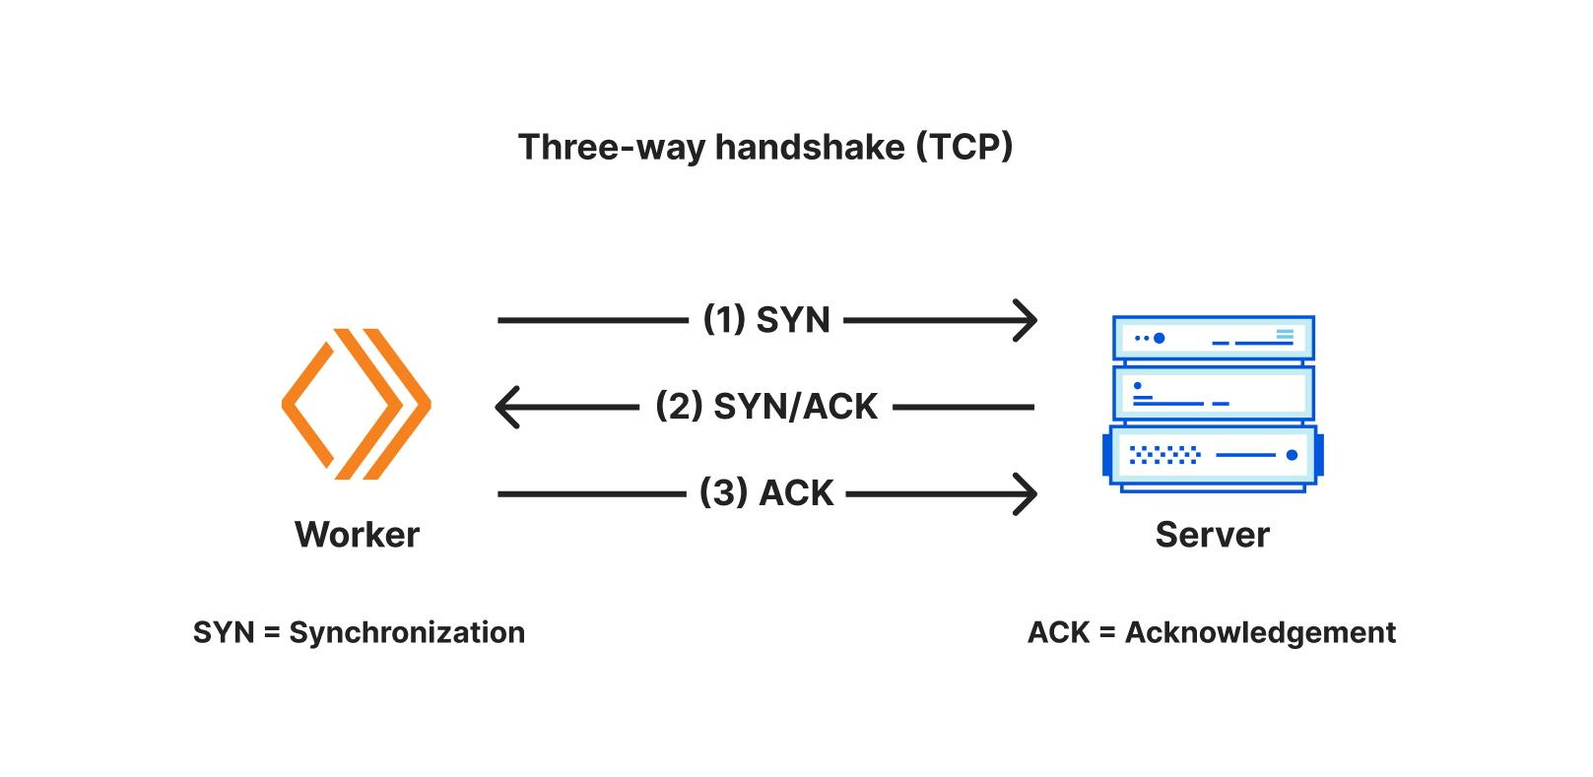
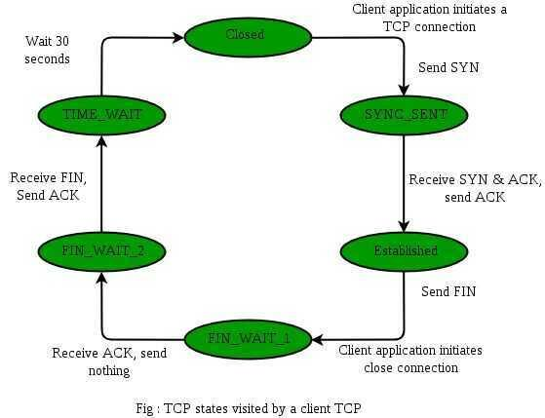
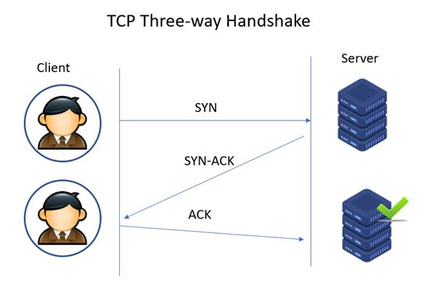
TCP establishes connection using:
- SYN
- SYN-ACK
- ACK

14. What is a Port?
Logical communication endpoint.
Examples:
- 80 → HTTP
- 443 → HTTPS
- 21 → FTP
- 22 → SSH

15. What is a Protocol?
Rules governing communication.
Examples:
- HTTP
- FTP
- SMTP
- TCP/IP

Devices Questions
16. Difference Between Hub, Switch and Router
Device | Function
Hub | Broadcasts to all
Switch | Uses MAC address
Router | Uses IP routing

17. What is Router?
Routes packets between networks.

18. What is Switch?
Connects devices in LAN.

19. What is Modem?
Converts digital ↔ analog signals.

20. What is Firewall?
Security system that filters traffic.

Important Protocol Questions
21. What is HTTP and HTTPS?
- HTTP = HyperText Transfer Protocol
- HTTPS = Secure HTTP (SSL/TLS)

22. What is FTP?
File Transfer Protocol.

23. What is SMTP, POP3, IMAP?
Email protocols.
- SMTP → Sending mail
- POP3 → Download mail
- IMAP → Sync mail

24. What is ARP?
Address Resolution Protocol maps IP → MAC.

25. What is ICMP?
Used for diagnostics.
Example:
ping command

Security Questions
26. What is VPN?
Virtual Private Network for secure communication.

27. What is Encryption?
Converting data into secure unreadable form.

28. Difference between Public IP and Private IP?
Private:
- 192.168.x.x
- 10.x.x.x
Public:
Internet accessible IP

Practical Commands Interview Questions
29. What does PING do?
Checks connectivity.
ping google.com

30. What is traceroute / tracert?
Shows route packets travel.
tracert google.com

31. What is ipconfig?
Displays IP settings (Windows)
ipconfig

Fresher HR + Technical Mixed Questions
32. What happens when you type google.com in browser?
Expected flow:
DNS → IP Resolution → TCP Handshake → HTTP Request → Server Response

33. Explain Packet Switching
Data broken into packets and transmitted separately.

34. What is Bandwidth?
Maximum data transfer capacity.

35. What is Latency?
Delay in packet travel.

Common Viva Questions
- What is topology?
- Types of topology?
- Difference between unicast, multicast, broadcast?
- What is packet?
- What is gateway?
- What is NAT?
- What is proxy server?
- What is collision?
- What is VLAN?

Frequently Asked Interviewer Favorites
- Explain OSI layers.
- TCP vs UDP.
- What happens when you open a website?
- Difference between switch and router.
- What is DNS?
- Explain subnet mask.
- What is ARP?
- What is ping?
- What is IP vs MAC address?
- Explain three-way handshake.

Mini MCQ Practice
Q1: Which layer does IP work on?
A) Transport
B) Network ✅
C) Session
D) Physical

Q2: Which protocol is connection-oriented?
A) UDP
B) TCP ✅

Q3: Port number for HTTPS?
A) 21
B) 80
C) 443 ✅

Q4: DNS stands for?
A) Dynamic Name System
B) Domain Name System ✅
Great — here are more Networking Interview Questions for BE Computer Engineering Freshers (interviewers often ask these to go beyond basics):
Advanced Fresher Networking Questions
36. What is Network Topology?
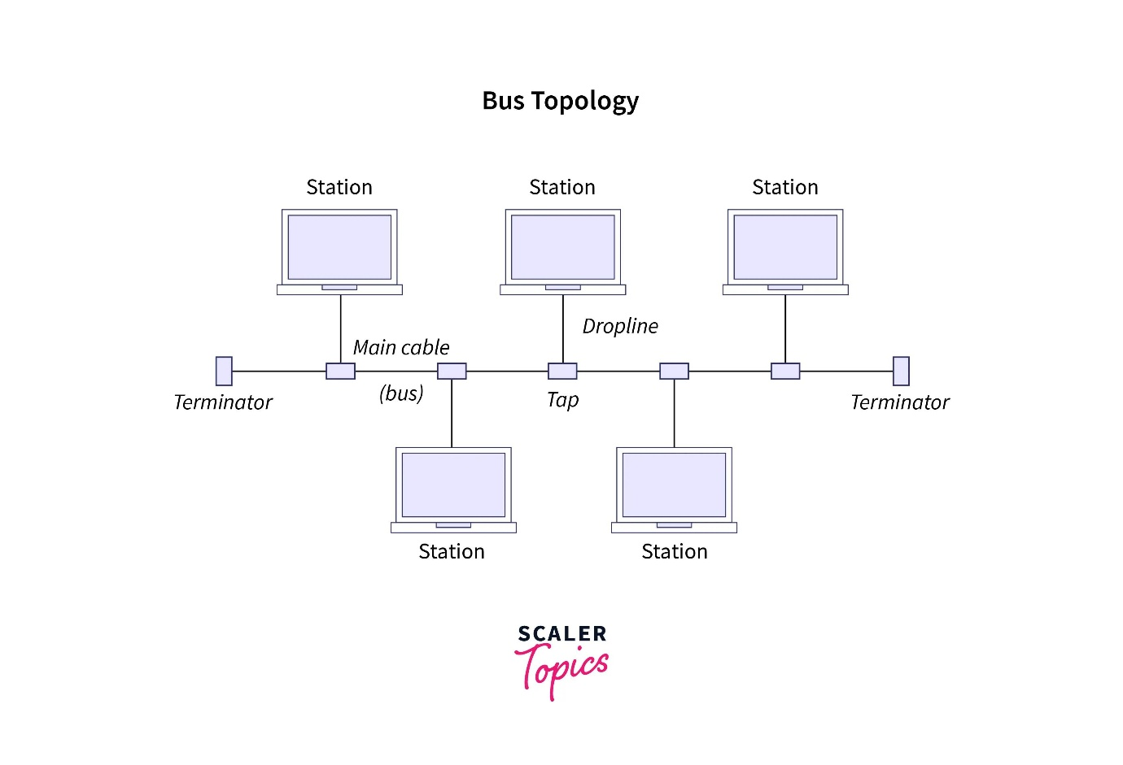
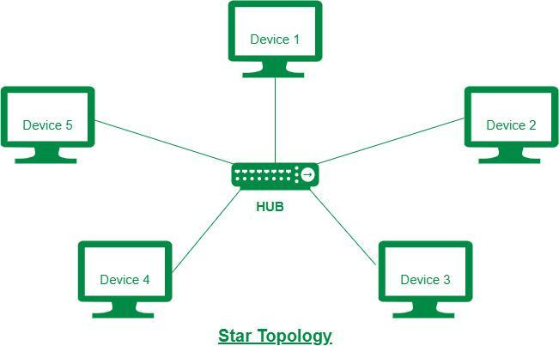
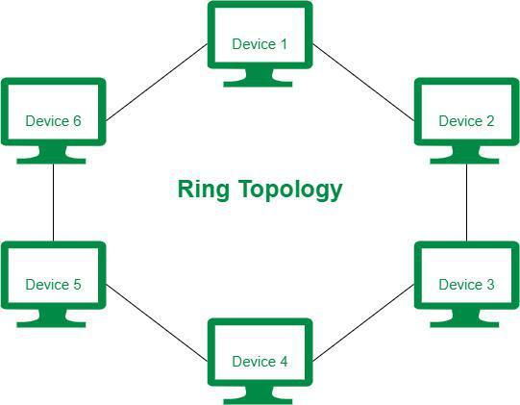
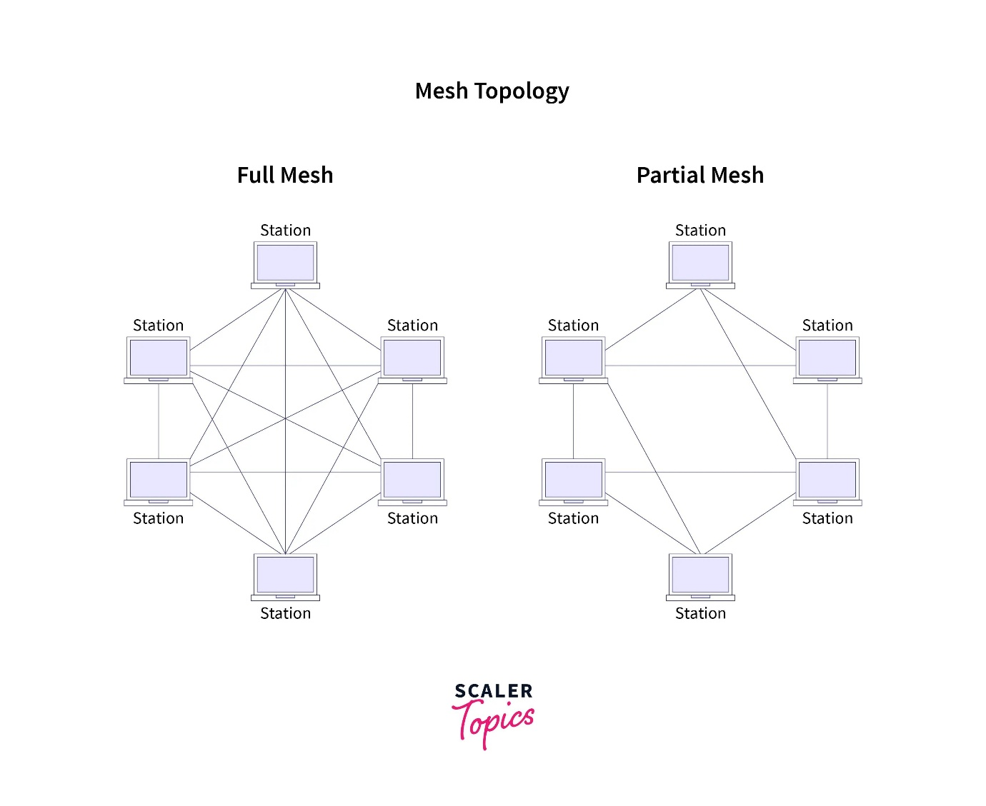
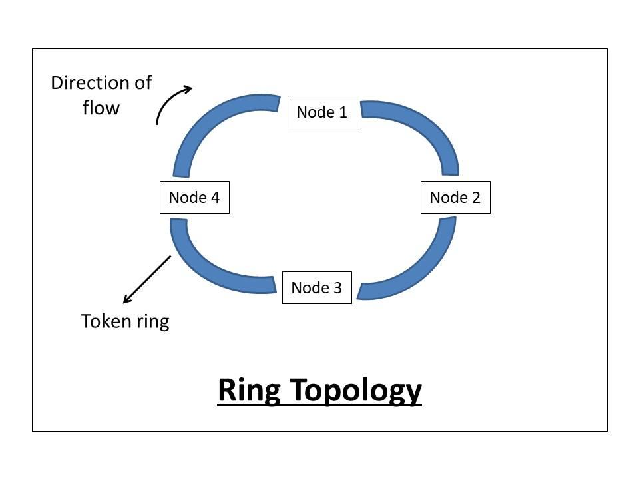
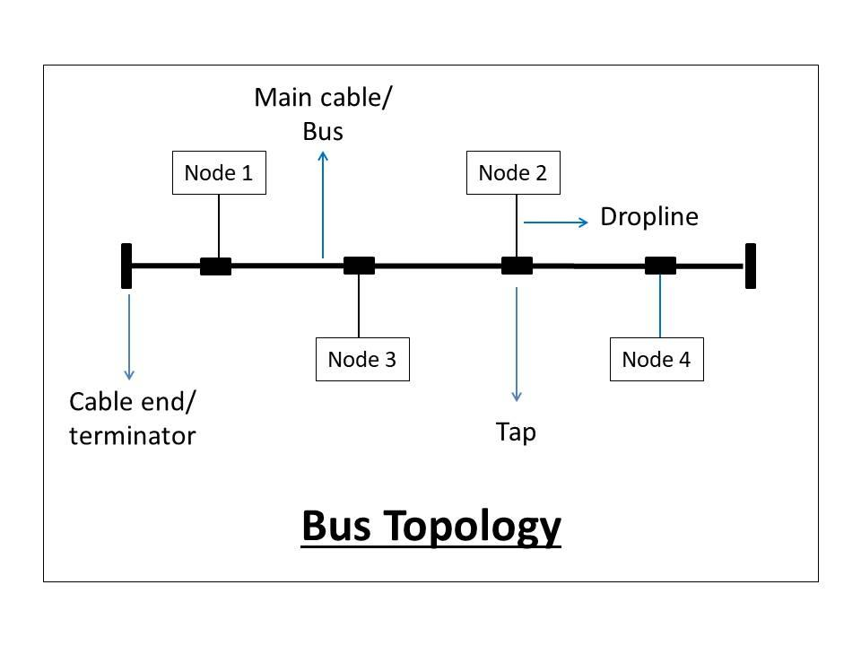
Types:
- Bus
- Star
- Ring
- Mesh
- Tree
Most used: Star topology

37. Difference between Unicast, Broadcast and Multicast
Type | Meaning
Unicast | One to One
Broadcast | One to All
Multicast | One to Many

38. What is NAT?
Network Address Translation
Converts private IP to public IP.
Example:
Many devices share one internet IP.

39. What is VLAN?
Virtual LAN divides one physical network into multiple logical networks.
Benefits:
- Security
- Reduced traffic
- Better management

40. What is Collision?
When two devices send data simultaneously.
Occurs in hubs.

41. What is CSMA/CD?
Carrier Sense Multiple Access/Collision Detection.
Used in Ethernet.

42. What is CSMA/CA?
Collision Avoidance.
Used in Wi-Fi.

Routing Questions
43. What is Routing?
Finding best path for packets.

44. What is Static Routing?
Manually configured routes.

45. What is Dynamic Routing?
Routes learned automatically.
Examples:
- OSPF
- RIP
- BGP

46. What is OSPF?
Open Shortest Path First.
Uses shortest path algorithm.

47. What is BGP?
Border Gateway Protocol.
Used on internet between ISPs.

48. What is RIP?
Routing Information Protocol.
Uses hop count.

TCP/IP Deep Questions
49. What is TCP Sliding Window?
Controls data flow between sender and receiver.

50. What is Flow Control?
Prevents receiver overload.

51. What is Congestion Control?
Controls excessive network traffic.
TCP methods:
- Slow Start
- Congestion Avoidance

52. What is Socket?
Combination of:
IP + Port
Used in network programming.

53. What is MTU?
Maximum Transmission Unit.
Maximum packet size.
Ethernet:
1500 bytes

54. What is TTL?
Time To Live.
Limits packet lifetime.

55. What is Fragmentation?
Breaking large packets into smaller packets.

Security Networking Questions
56. What is SSL/TLS?
Provides secure communication.
Used in HTTPS.

57. What is SSH?
Secure Shell.
Remote secure login.
Port 22

58. Difference between Symmetric and Asymmetric Encryption
Symmetric | Asymmetric
One key | Two keys
Fast | More secure

59. What is a Proxy Server?
Intermediate server between client and internet.

60. What is IDS and IPS?
IDS:
Intrusion Detection System
IPS:
Intrusion Prevention System

Wireless Networking Questions
61. What is Wi-Fi?
Wireless networking technology.

62. Difference between 2.4 GHz and 5 GHz
2.4 GHz | 5 GHz
Long range | Higher speed
More interference | Less interference

63. What is SSID?
Wi-Fi network name.

64. What is Access Point?
Device providing wireless connectivity.

65. Difference between Bluetooth and Wi-Fi
Bluetooth | Wi-Fi
Short range | Longer range
Low power | Higher speed

Scenario Based Interview Questions
66. Ping works but website not opening. Why?
Possible reasons:
- DNS issue
- Browser issue
- Firewall
- Server down

67. Internet connected but slow. Reasons?
- Bandwidth issue
- Congestion
- Packet loss
- High latency

68. System gets IP 169.254.x.x — why?
APIPA address.
DHCP failed.

69. How do you troubleshoot no network?
Check:
- Cable
- IP Config
- Ping localhost
- Ping gateway
- Ping internet
- Check DNS

Important Port Numbers (Very Common)
Memorize these:
Protocol | Port
HTTP | 80
HTTPS | 443
FTP | 21
SSH | 22
Telnet | 23
SMTP | 25
DNS | 53
DHCP | 67/68

Tricky Interview Questions
70. Difference between Hub and Switch?
Hub broadcasts all.
Switch forwards intelligently using MAC.

71. Why TCP is reliable?
- ACK
- Retransmission
- Sequencing

72. What happens if subnet mask is wrong?
Communication failure.

73. Why use MAC if IP exists?
IP can change.
MAC is unique hardware address.

74. Why is ARP needed?
IP communication requires MAC.
ARP resolves it.

Freshers Viva Questions
- What is packet sniffing?
- What is packet loss?
- What is gateway vs router?
- Difference between LAN and VLAN?
- What is load balancing?
- What is QoS?
- What is DNS cache?
- What is DHCP lease?
- What is duplex mode?
- What is port forwarding?

Mini MCQs
75. Which protocol uses port 53?
A FTP
B DNS ✅
C HTTP
D SSH

76. Which device works at Network Layer?
A Hub
B Switch
C Router ✅

77. APIPA address starts with
A 10.x.x.x
B 169.254.x.x ✅

78. BGP is used for
A LAN
B Internet routing ✅

Complete Networking Interview Pack (BE Computer Engineering Fresher)
Part 1 — CCNA/Cisco Style Interview Questions
1. What is a Router?
A Layer 3 device that forwards packets based on IP addresses.

2. What is a Switch?
A Layer 2 device that forwards frames using MAC addresses.

3. Difference Between Router and Switch
Switch | Router
Works on MAC | Works on IP
Layer 2 | Layer 3
Within LAN | Connects networks

4. What is Cisco IOS?
Internetwork Operating System used on Cisco devices.

5. What is a Default Gateway?
Router address used to reach external networks.

6. Common Cisco Commands
enable
configure terminal
show ip interface brief
show running-config
show version
copy run start

7. What is VLAN?
Virtual LAN logically segments networks.
Example:
- VLAN 10 HR
- VLAN 20 Finance
- VLAN 30 IT

8. What is Trunk Port?
Carries traffic for multiple VLANs.

9. Access Port vs Trunk Port
Access | Trunk
One VLAN | Multiple VLANs
PC Connection | Switch-to-switch

10. What is STP?
Spanning Tree Protocol.
Prevents loops.

11. What is Loop in Network?
Packets circulate endlessly causing broadcast storms.

12. What is Inter-VLAN Routing?
Allows communication between VLANs using router or Layer-3 switch.

13. What is Subnetting?
Dividing one network into smaller networks.
Example:
192.168.1.0/24
can become
192.168.1.0/26
192.168.1.64/26

14. What is CIDR?
Classless Inter Domain Routing.
Example:
/24
/16
/30

15. What is ACL?
Access Control List.
Filters traffic.
Types:
- Standard ACL
- Extended ACL

Part 2 — Troubleshooting Interview Round
16. User cannot access internet. Steps?
1 Check cable
2 Check IP address
3 Ping localhost
4 Ping gateway
5 Ping 8.8.8.8
6 Check DNS

17. Ping IP works but domain doesn't
Likely DNS issue.

18. Duplicate IP problem symptoms
- Intermittent disconnect
- IP conflict warning

19. High latency causes
- Congestion
- Packet loss
- Weak signal

20. Command Line Troubleshooting
ping
tracert
ipconfig /all
netstat
nslookup
arp -a

Part 3 — Frequently Asked Viva Questions
21 What is ARP?
22 What is RARP?
23 What is NAT?
24 PAT vs NAT?
25 What is DHCP Lease?
26 What is Broadcast Domain?
27 What is Collision Domain?
28 What is QoS?
29 What is MTU?
30 What is Port Forwarding?

Part 4 — 50 Networking MCQs
MCQ Set
1.
OSI has how many layers?
A 5
B 6
C 7 ✅
D 8

2.
IP works at:
A Physical
B Data Link
C Network ✅
D Transport

3.
Switch works on:
A IP
B MAC ✅
C Port
D DNS

4.
Router works at:
A Layer 1
B Layer 2
C Layer 3 ✅
D Layer 7

5.
Port of HTTPS
A 80
B 21
C 443 ✅
D 25

6.
DNS uses port:
A 22
B 53 ✅
C 80
D 443

7.
Which protocol is reliable?
A UDP
B TCP ✅

8.
Which is connectionless?
A TCP
B UDP ✅

9.
ARP maps:
A MAC to IP
B IP to MAC ✅

10.
APIPA starts with:
A 10.
B 172.
C 192.
D 169.254 ✅

11.
FTP Port:
21 ✅
12.
SSH Port:
22 ✅
13.
SMTP Port:
25 ✅
14.
Telnet Port:
23 ✅
15.
DHCP stands for?
Dynamic Host Configuration Protocol ✅

16.
Device connecting networks:
Router ✅
17.
Hub is:
Layer 1 ✅
18.
Switch is:
Layer 2 ✅
19.
BGP used for:
Internet routing ✅
20.
RIP metric:
Hop Count ✅

21.
Protocol for email sending:
SMTP ✅
22 POP3 receives mail
23 ICMP used by Ping
24 VLAN means Virtual LAN
25 OSPF means Open Shortest Path First
26 Full form LAN
Local Area Network
27 Full form WAN
Wide Area Network
28 Full form MAN
Metropolitan Area Network
29 IPv4 bits
32
30 IPv6 bits
128
31 MAC address is physical address
32 Firewall provides security
33 VPN means Virtual Private Network
34 HTTP is unsecured
35 HTTPS is secure
36 CSMA/CD used in Ethernet
37 CSMA/CA used in WiFi
38 Default subnet mask class C
255.255.255.0
39 Loop prevented by
STP
40 Packet loss means dropped packets
41 Which layer has TCP
Transport
42 Which layer has IP
Network
43 DNS converts names to IP
44 Traceroute shows path
45 Broadcast sends to all
46 Multicast sends to many
47 Unicast one to one
48 Router uses routing table
49 NAT saves public IPs
50 Gateway connects outside network

Part 5 — Scenario Based Interview Questions (Very Common)
Explain what happens when you open google.com?
Answer:
1 Browser checks cache
2 DNS resolution
3 TCP 3-way handshake
4 HTTP/HTTPS request
5 Server response
6 Page loads

What is difference between ping and traceroute?
Ping checks reachability.
Traceroute checks route.

Why use TCP over UDP?
Reliability.

If one system in LAN can't talk to others?
Check:
- IP
- Subnet mask
- Cable
- Switch port
- Firewall

Part 6 — HR + Networking Combined Questions
1 Tell me about OSI model.
2 Explain TCP handshake.
3 Explain DNS.
4 Explain subnetting.
5 Difference TCP and UDP.
6 What is packet switching?
7 Why networking interests you?
8 What is your final year networking project?
9 Difference hub switch router.
10 Explain VLAN.

Part 7 — Interviewer Favorite Tricky Questions
Q Why 127.0.0.1 used?
Loopback.
Q Why MAC and IP both needed?
Logical + Physical addressing.
Q Why switch better than hub?
Less collision.
Q Why subnetting used?
Security + efficient IP usage.
Q Why use VLAN?
Segmentation.

Mini Rapid Fire (Very Common)
What is:
- NAT
- PAT
- DHCP
- DNS
- VPN
- Firewall
- Proxy
- ACL
- STP
- OSPF
- BGP
- RIP
- VLAN
- MTU
- TTL
Prepare one-line answers.

Top Companies Fresher Networking Questions
TCS/Infosys
Mostly basics:
- OSI
- TCP UDP
- IP classes
- DNS
- Ports
Cognizant/Accenture
- Troubleshooting
- Networking commands
- Scenario questions
Cisco Support Roles
- VLAN
- Routing
- Subnetting
- STP
- ACL

Very Important Subnetting Questions Interviewers Ask
1 Find hosts in /24
254
2 Hosts in /30
2 usable
3 Hosts in /29
6 usable
4 Why /30 used?
Point-to-point links.

Must Memorize Ports
80 HTTP
443 HTTPS
20/21 FTP
22 SSH
23 Telnet
25 SMTP
53 DNS
67 DHCP Server
68 DHCP Client
110 POP3
143 IMAP

Bonus Practical Lab Questions
Configure IP in Cisco
conf t
interface fa0/1
ip address 192.168.1.1 255.255.255.0
no shutdown

Save config
copy running-config startup-config

Show interfaces
show ip interface brief

Final Interview Preparation Tip
Focus these 15 topics strongly:
1 OSI Model
2 TCP/IP
3 TCP vs UDP
4 IP Addressing
5 Subnetting
6 DNS
7 DHCP
8 VLAN
9 Routing
10 NAT
11 ARP
12 Ports
13 Troubleshooting
14 Cisco commands
15 Network security basics
If you master these, you can clear most fresher interviews.

Advanced Networking Interview Questions (Fresher → Higher Level)
1) Explain encapsulation and decapsulation.
- At sender:
Application Data → TCP Segment → IP Packet → Ethernet Frame → Bits
- At receiver:
Bits → Frame → Packet → Segment → Data

2) Explain packet vs frame vs segment.
- Segment → Transport layer (TCP)
- Packet → Network layer (IP)
- Frame → Data Link layer
Common interview favorite.

3) Difference between circuit switching and packet switching?
Circuit Switching | Packet Switching
Dedicated path | No dedicated path
Telephone | Internet
Reliable | Efficient

4) Explain TCP 3-Way Handshake
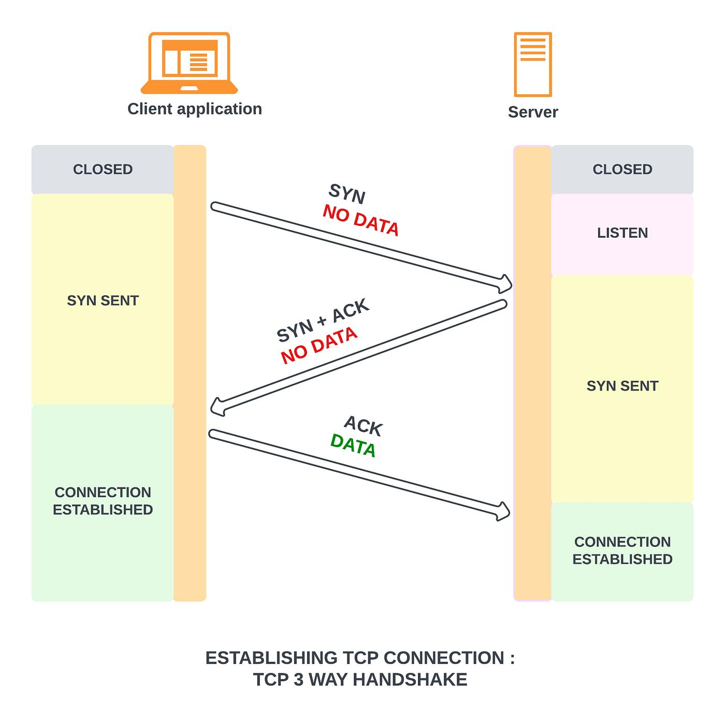
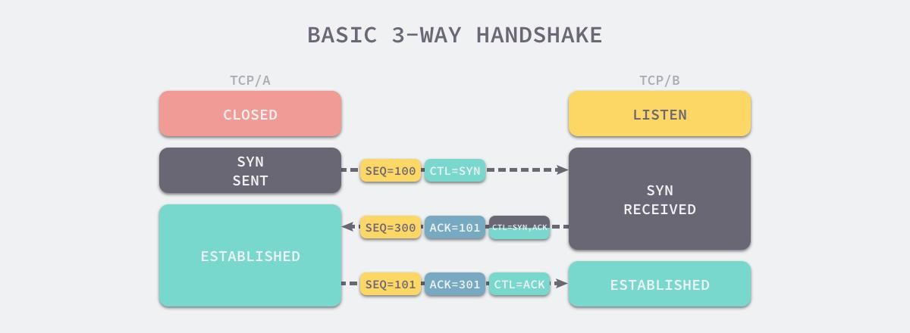
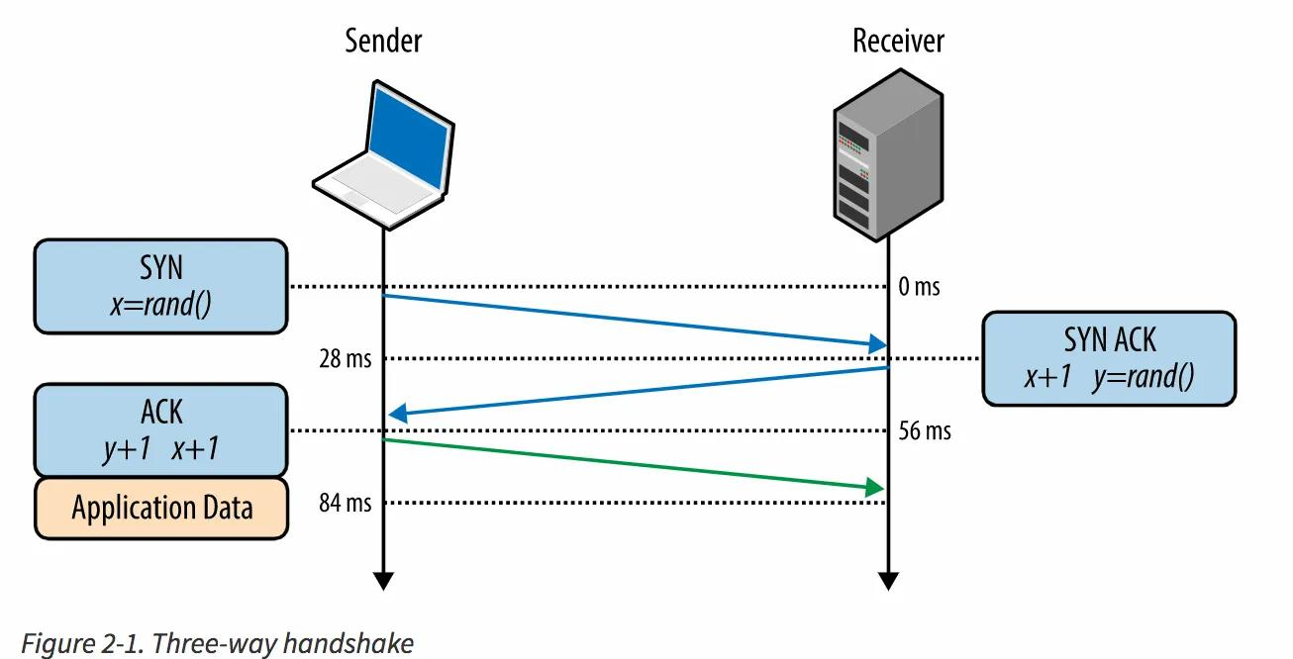

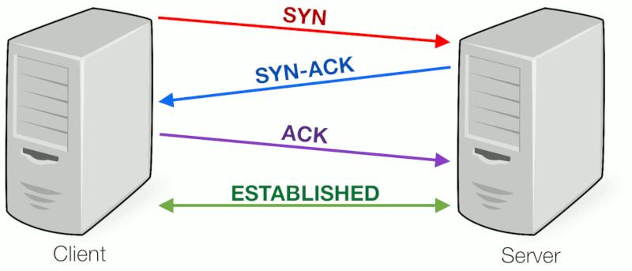
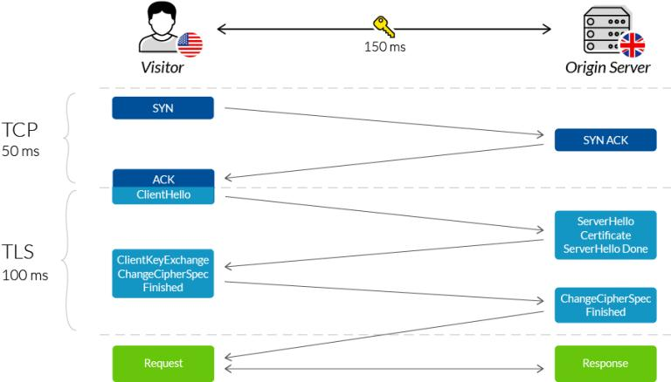
1 SYN
2 SYN-ACK
3 ACK
Connection established.

5) Explain TCP 4-way termination
FIN
ACK
FIN
ACK

6) What is sliding window protocol?
Controls flow of packets and acknowledgments.

7) What is Stop-and-Wait vs Sliding Window?
Stop Wait | Sliding Window
One packet at a time | Multiple packets
Slow | Faster

8) What is checksum?
Error detection mechanism.

9) Difference between error detection and correction?
- Detection → CRC, checksum
- Correction → Hamming code

10) Explain CRC.
Cyclic Redundancy Check detects transmission errors.

Advanced IP Questions
11) Explain CIDR notation.
192.168.1.0/24
/24 means 24 network bits.

12) What is subnetting?
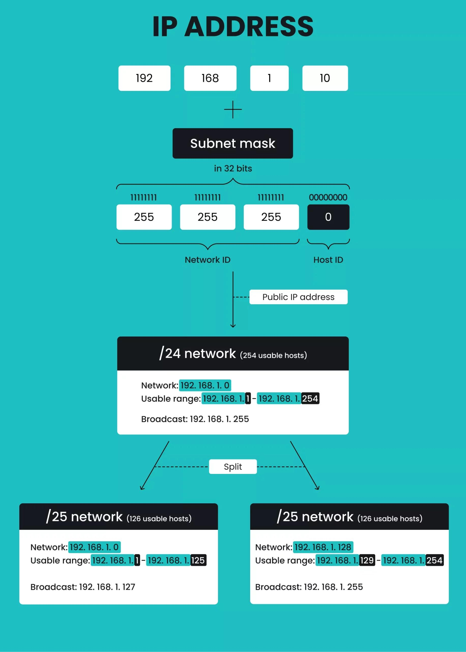
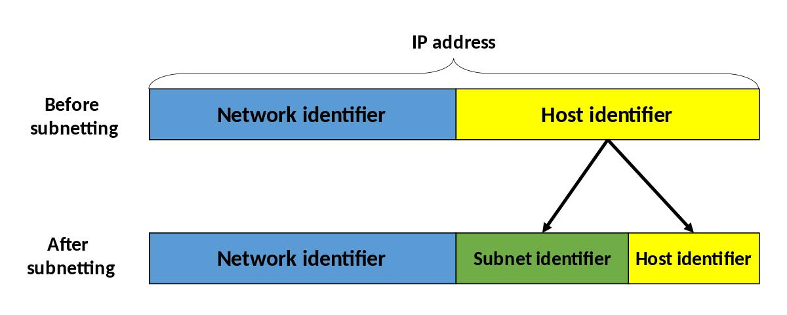
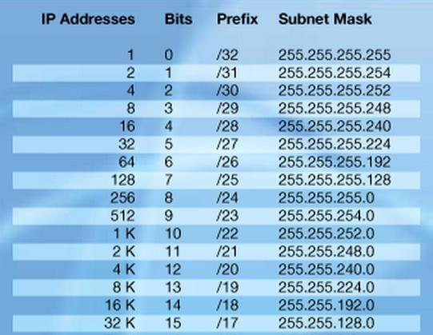
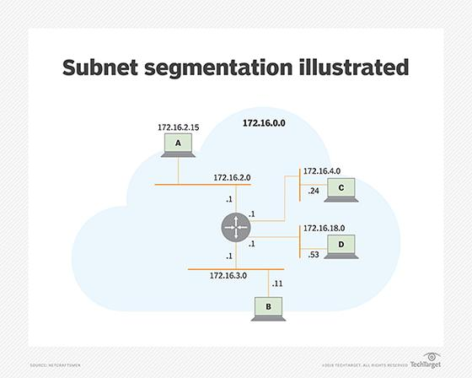
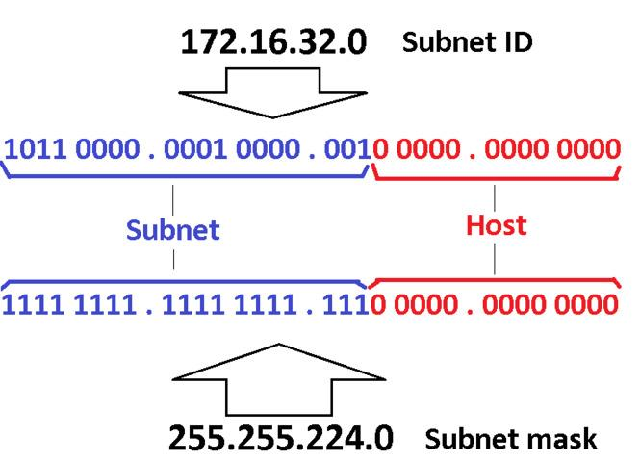
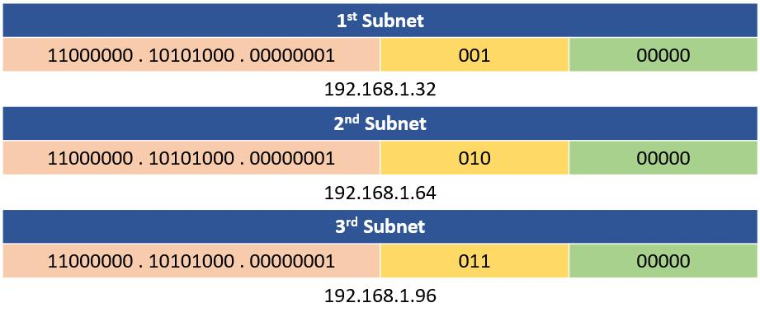
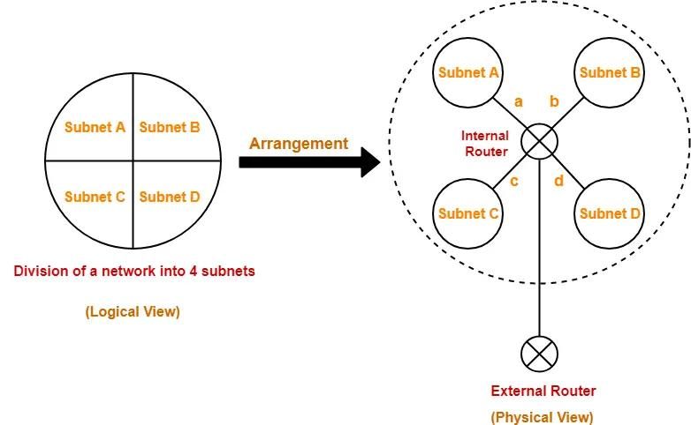
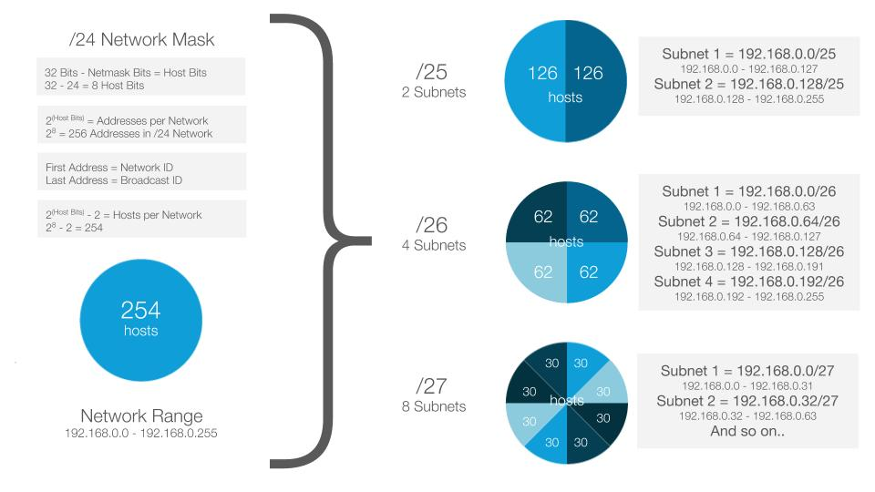
Dividing network into smaller networks.
Possible question:
Find hosts in /27
Answer:
32 addresses
30 usable hosts

13) Difference between subnetting and supernetting.
Subnetting:
Split network.
Supernetting:
Combine networks.

14) What is NAT vs PAT?
NAT:
One private ↔ one public
PAT:
Many private share one public

15) Explain private IP ranges.
- 10.0.0.0/8
- 172.16–31
- 192.168.0.0/16

Routing Advanced
16) Distance Vector vs Link State
Distance Vector | Link State
RIP | OSPF
Slow | Faster
Hop count | SPF algorithm

17) What is Dijkstra Algorithm?
Used by OSPF for shortest path.

18) What is routing table?
Stores path information.

19) Static vs Dynamic Routing?
Classic interview.

20) What is default route?
0.0.0.0/0
Route of last resort.

Switching Advanced
21) What is Spanning Tree Protocol?
Prevents switching loops.

22) What is Broadcast Storm?
Excessive broadcasts flood network.

23) What is collision domain vs broadcast domain?
Switch:
Each port collision domain.
Router:
Breaks broadcast domains.

24) What is trunking?
Carries multiple VLAN traffic.

25) What is inter-VLAN routing?
Communication between VLANs.

Security Questions
26) Symmetric vs Asymmetric encryption
Examples:
Symmetric:
- AES
Asymmetric:
- RSA

27) What is SSL handshake?
May be asked in advanced interviews.

28) What is Man in the Middle attack?
Security concept question.

29) Difference between IDS and IPS?
Common security round.

30) What is firewall stateful inspection?
Advanced security question.

Protocol Deep Questions
31) How DNS resolution works?
Browser → Resolver → Root → TLD → Authoritative DNS
Very common advanced question.

32) Difference HTTP vs HTTPS?
Use TLS encryption.

33) What happens when you open google.com?
Classic interview favorite.
Full answer:
- DNS lookup
- ARP
- TCP handshake
- TLS (if HTTPS)
- HTTP request
- Response

34) Explain ARP process.
“How does one machine find another MAC?”

35) What is ARP Spoofing?
Advanced security question.

Troubleshooting Scenario Questions
36) Ping gateway works but internet doesn't.
Possible:
- DNS
- ISP
- Default route

37) Cannot ping by hostname but IP works?
DNS issue.

38) Duplicate IP issue symptoms?
Conflict.

39) Packet loss reasons?
- Congestion
- Errors
- Bad cable

40) Why latency happens?
- Distance
- Routing
- Queueing

Interviewer Tricky Questions
41) Why TCP reliable but UDP faster?

42) Why use UDP for video streaming?

43) Why does switch need MAC table?

44) Why ARP not use TCP?

45) Why TTL needed?

46) Why fragmentation happens?

47) Why MTU mismatch causes issue?

48) Explain SYN flood attack.

49) Why ports needed if IP exists?

50) Explain socket.
IP + Port

Advanced Fresher MCQs
Which protocol uses Dijkstra?
A RIP
B OSPF ✅

Default route is
A 127.0.0.1
B 0.0.0.0/0 ✅

Broadcast storm prevented by
A DHCP
B STP ✅

ARP maps
IP → MAC ✅

Which protocol unreliable but fast
UDP ✅

CCNA / CCNP Lab Interview Questions with Answers (Hands-On Round)
Subnetting Problems with Answers
1) How many usable hosts in /24?
Answer:
256 total
254 usable

2) Hosts in /30?
Answer:
4 total
2 usable
Used for point-to-point links.

3) Hosts in /29?
Answer:
8 total
6 usable.

4) Find Network ID
IP: 192.168.10.45/27
Answer:
Network ID: 192.168.10.32
Broadcast: 192.168.10.63
Hosts: .33 to .62

5) Divide 192.168.1.0/24 into 4 subnets
Answer:
/26 subnets:
192.168.1.0
192.168.1.64
192.168.1.128
192.168.1.192

Cisco Configuration Lab Questions
6) Configure IP on Router
Question:
Configure router interface with:
IP 192.168.1.1/24
Answer:
enable
conf t
interface g0/0
ip address 192.168.1.1 255.255.255.0
no shutdown

7) Configure Static Route
Question:
Reach 10.0.0.0 via 192.168.1.2
Answer:
ip route 10.0.0.0 255.0.0.0 192.168.1.2

8) Default Route Configuration
ip route 0.0.0.0 0.0.0.0 192.168.1.254

VLAN Lab
9) Create VLAN 10
conf t
vlan 10
name SALES

10) Assign Port to VLAN
interface fa0/1
switchport mode access
switchport access vlan 10

11) Configure Trunk
interface fa0/24
switchport mode trunk

12) Verify VLANs
show vlan brief

OSPF Labs
13) Configure OSPF
router ospf 1
network 192.168.1.0 0.0.0.255 area 0

14) Verify OSPF Neighbors
show ip ospf neighbor

15) OSPF Adjacency not forming — troubleshoot?
Check:
- Area mismatch
- Hello timer
- Authentication
- MTU mismatch

ACL Lab Questions
16) Standard ACL Example
Permit 192.168.1.0 network:
access-list 10 permit 192.168.1.0 0.0.0.255

17) Extended ACL Example
Block Telnet:
access-list 101 deny tcp any any eq 23
access-list 101 permit ip any any

NAT Lab
18) Configure NAT basic
ip nat inside
ip nat outside

19) PAT Example
ip nat inside source list 1 interface g0/0 overload

STP Labs
20) Make Switch Root Bridge
spanning-tree vlan 1 root primary

21) Enable PortFast
spanning-tree portfast

22) Enable BPDU Guard
spanning-tree bpduguard enable

Troubleshooting Lab Scenarios
23) Interface down/down means?
Possible:
- Cable disconnected
- Device off

24) Interface up/down means?
Layer 2 issue.
Encapsulation mismatch.

25) Interface errors increasing?
Check:
show interfaces
Possible CRC/duplex issue.

26) User can’t reach gateway
Check:
- VLAN
- IP
- Mask
- Port assignment

27) OSPF stuck EXSTART
Usually MTU mismatch.

28) Switch loop suspected
Use:
show spanning-tree

Packet Analysis Questions
29) How identify TCP handshake in packet capture?
SYN
SYN ACK
ACK

30) Identify retransmissions in Wireshark.
Repeated sequence numbers.

CCNP Style Tough Questions
31) Explain Route Redistribution Example.
Redistribute RIP into OSPF:
router ospf 1
redistribute rip subnets

32) Summarization Example
area 1 range 10.1.0.0 255.255.0.0

33) Floating Static Route?
Backup route with higher AD.
Example:
ip route 10.0.0.0 255.0.0.0 192.168.1.2 200

34) Verify Routing Table
show ip route

35) Show MAC Table
show mac address-table

Lab Interview Rapid Fire
- Difference running-config and startup-config?
- Command save configuration?
copy run start
- Show CDP neighbors?
show cdp neighbors
- Show LLDP neighbors?
show lldp neighbors
- Check trunk interfaces?
show interfaces trunk

Common Practical Interview Tasks
Task 1
Configure:
- 2 VLANs
- trunk
- inter-vlan routing
- verify connectivity

Task 2
Given 3 routers:
Configure OSPF adjacency.

Task 3
Given broken connectivity:
Troubleshoot.

Task 4
Configure ACL blocking Telnet but allow Ping.

Task 5
Configure PAT for internet access.

Interviewers May Give Debug Scenarios
- Why OSPF neighbor Full not forming?
- Why BGP idle state?
- Why VLAN hosts isolated?
- Why pings fail one direction?
- Why trunk not passing VLAN?
- Why routes not learned?
- Why interface shows CRC errors?
- Why packet drops under load?
- Why STP blocking unexpected port?
- Why DHCP clients not receiving IP?

Most Important Show Commands
Memorize:
show ip route
show ip interface brief
show interfaces
show vlan brief
show spanning-tree
show ip ospf neighbor
show mac address-table
show arp
show cdp neighbors
show running-config

Interview Favorite Subnet Problems
- Find broadcast for 172.16.10.34/28
- Design subnet for 100 hosts.
- Design subnet for 500 hosts.
- VLSM problem.
- Find first usable /27 subnet.

Bonus TAC Scenarios
- Packet loss only during peak hours — why?
- High CPU on router troubleshoot.
- Intermittent BGP flaps.
- One application slow but ping okay.
- VPN tunnel unstable.

